Mobile Development

Game Concept
You play as a baker in a small town, making pastries and desserts as they are ordered. In this merge game, you merge items to make specific ingredients, and combine the right ingredients to make your pastry. Taking inspiration from Suika Game, make sure you don’t merge too many incorrect ingredients, or risk losing your order. Earn money from fulfilled orders to spend on upgrading your menu, your ingredient quality, and more.

Intended Audience and Target Platform
The intended audience, like most mobile games, is casual gamers who can pick up the game any time, play for a few minutes, and be satisfied. The age range is likely to be teenagers and adults, since the game is slightly complex, though I’m hoping to make my game appealing to as many people as possible, so I am not aiming for a specific age range.
For this project, my target platform is Android players with a range of device capabilities. I hope to achieve this by making my game optimised and accessible so it can be played on as many devices as possible. Since I am aiming to appeal to casual players, I will make my game in a portrait orientation rather than a landscape one.

Core Gameplay Loop
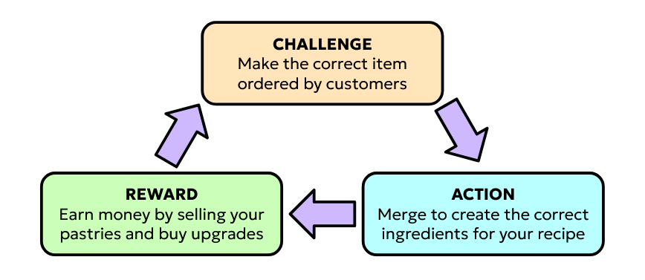

Project Objectives
My game concept features an easy-to-understand theme, simple yet rewarding gameplay loop, and a genre primarily found on mobile games.
The player is presented with a baked good they must craft by merging the ingredients they have in their bakery and following a recipe.
Using a mix of the merging systems in Suika Game and Merge Mansion, the player is presented with an item they drop onto a grid. When placed, the item falls in a similar way to tetris blocks and lands on the next available grid space directly below it. They have to strategically place items in the grid and aim for three of the same icons in a row in order to merge them into the next tier of item and repeat the cycle until they merge enough to earn their required item.
If all grid spaces fill up, the game is lost. If they earn all three required items before filling up the grid, they win the merge round and successfully complete the order to sell to a customer.
Winning earns the player a set amount of money depending on how hard an item is to create. With money earned they can buy upgrades and boosts to make orders more profitable, or make managing their merge grid easier. They can also unlock more recipes to sell at the bakery.

The mobile specific features I have in mind currently are:
- Haptic Feedback
- Unity Leaderboards
- Local Notifications
- Unity Cloud Save

Haptic Feedback is the first feature I will aim for, as it will help my game feel more immersive and interactive to the player if it vibrates upon merging or upon finishing a pastry. Local Notifications can remind the player to keep coming back, which is especially useful for the casual playstyle game I am aiming to create, and this one is my second highest priority mobile feature.

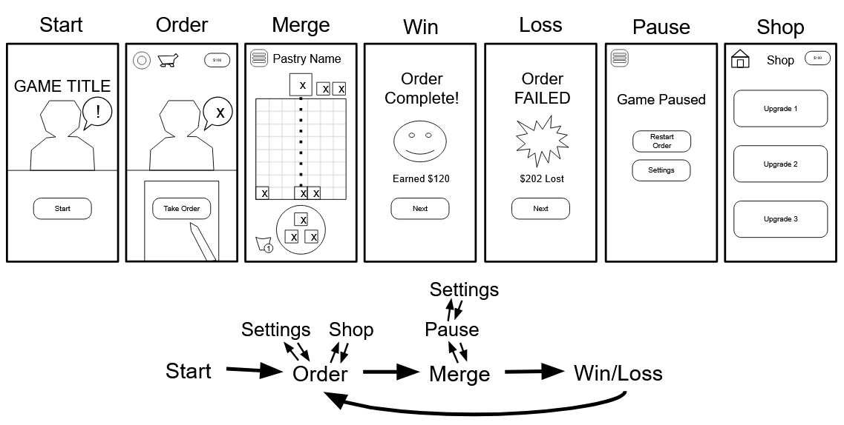
Interface Wireframes & Control Planning

Wireframes of all interface screens in the game, and a small diagram of how and where each one can be accessed from.

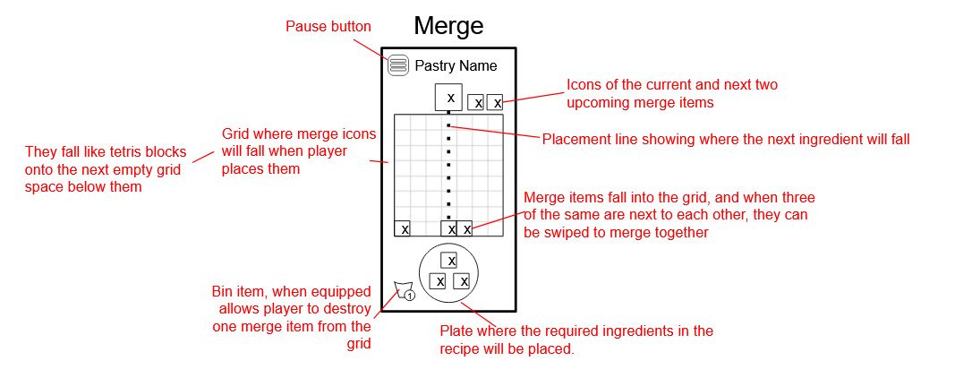

Labels on the wireframe of the main gameplay screen to illustrate the purpose of each item.

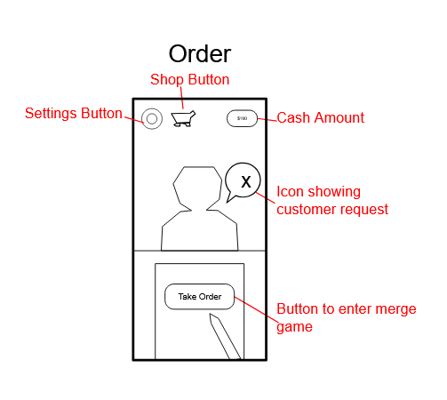
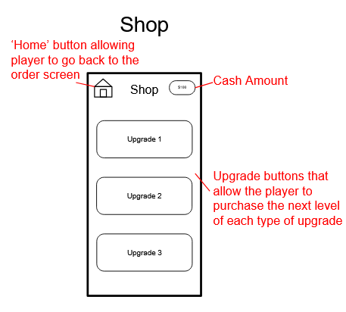

Labelled wireframes of the shop and order screens.

I’ve designed these game screens with mobile control in mind. The most vital areas of gameplay are all controllable by touching anywhere on the bottom of the screen, allowing for one-handed playing that's easy to reach with just the thumb. Players can start the game, merge items, and complete their pastry all with one hand.
Actions like accessing the shop, pausing, and using boosts are of a lower priority in gameplay and will be performed by the player less frequently. Therefore, buttons for these actions have been put in areas that are less reachable by the thumb and may need a second hand to be reached.

Control Scheme:
Hold & Drag - move placement guide or move selected item
Swipe - Merge 3 matching items into the next tier of item
Tap - interact, press buttons
Tap & Hold - Continue buying upgrade until the button is let go

